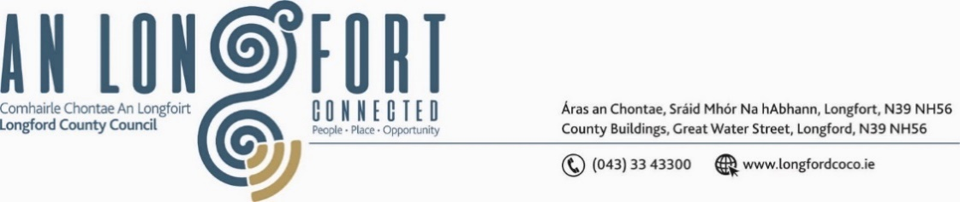

***LONGFORD MUNICIPAL DISTRICT***

***Please note meeting will be held in The Council Chamber, Aras an Chontae.***

**17 June 2024**

**To: Each Member of Longford Municipal District.**

A Chomhairleoir,

You are requested to attend the Annual Meeting of Longford Municipal District to be held in **The Council Chamber on Monday, 24 June 2024 at 3pm** to transact business, as set out on the Agenda hereunder.

Mise le meas,

Claire McNabola

______________

**Claire McNabola,**

**Meetings Administrator.**

**C L A R**

**1**.      Election of Cathaoirleach.

**2.**      Election of Leas Cathaoirleach.

**3.**      Nominations to Committees – referred from Longford County Council

          2024 Annual Meeting

**4**.      Fix date and time of Longford Municipal District meetings.